Day 3 Lab Manual Part 2

BIVARIATEANALYSIS IN R -COVARIANCE, CORRELATION, CROSSTAB

name:p.barath

reg no: 192121147

Exercise: 8

Reference Status Gender TestNewOrFollowUp

1 KRXH Accepted Female Test1 New

2 KRPT Accepted Male Test1 New

3 FHRA Rejected Male Test2 New

4 CZKK Accepted Female Test3 New

5 CQTN Rejected Female Test1 New

6 PZXW Accepted Female Test4 Follow-up

7 SZRZ Rejected Male Test4 New

8 RMZE Rejected Female Test2 New

9 STNX Accepted Female Test3 New

10 TMDW Accepted Female Test1 New

i) Load the dataset and Create a data frame and name it as dataframe1

ii) Load the function for crosstab

Note: Perform status+gender

Gender

Status Female Male

Accepted 5 1

Rejected 2 2

Note: Reference+Status

Status

Reference Accepted Rejected

CQTN 0 1

CZKK 1 0

FHRA 0 1

KRPT 1 0

KRXH 1 0

PZXW 1 0

RMZE 0 1

STNX 1 0

SZRZ 0 1

TMDW 1 0

INPUT:

Reference <- c("KRXH", "KRPT", "FHRA", "CZKK", "CQTN", "PZXW",

"SZRZ", "RMZE", "STNX", "TMDW")

Status <- c("Accepted", "Accepted", "Rejected", "Accepted", "Rejected", "Accepted",

"Rejected", "Rejected", "Accepted", "Accepted")

Gender <- c("Female", "Male", "Male", "Female", "Female", "Female", "Male",

"Female", "Female", "Female")

TestNewOrFollowUp <- c("Test1", "Test1", "Test2", "Test3", "Test1", "Test4",

"Test4", "Test2", "Test3", "Test1")

dataframe1 <- data.frame(Reference, Status, Gender, TestNewOrFollowUp)

print(dataframe1)

# Assuming you have already created dataframe1 as shown above

2.# Crosstab of Status and Gendera

cross_tab <- table(dataframe1$Status, dataframe1$Gender)

print(cross_tab)

OUTPUT:> Reference <- c("KRXH", "KRPT", "FHRA", "CZKK", "CQTN", "PZXW",

+ "SZRZ", "RMZE", "STNX", "TMDW")

> Status <- c("Accepted", "Accepted", "Rejected", "Accepted", "Rejected", "Accepted",

+ "Rejected", "Rejected", "Accepted", "Accepted")

> Gender <- c("Female", "Male", "Male", "Female", "Female", "Female", "Male",

+ "Female", "Female", "Female")

> TestNewOrFollowUp <- c("Test1", "Test1", "Test2", "Test3", "Test1", "Test4",

+ "Test4", "Test2", "Test3", "Test1")

>

> dataframe1 <- data.frame(Reference, Status, Gender, TestNewOrFollowUp)

> print(dataframe1)

Reference Status Gender TestNewOrFollowUp

1 KRXH Accepted Female Test1

2 KRPT Accepted Male Test1

3 FHRA Rejected Male Test2

4 CZKK Accepted Female Test3

5 CQTN Rejected Female Test1

6 PZXW Accepted Female Test4

7 SZRZ Rejected Male Test4

8 RMZE Rejected Female Test2

9 STNX Accepted Female Test3

10 TMDW Accepted Female Test1

> # Assuming you have already created dataframe1 as shown above

>

> 2.# Crosstab of Status and Gender

[1] 2

> cross_tab <- table(dataframe1$Status, dataframe1$Gender)

> print(cross_tab)

Female Male

Accepted 5 1

Rejected 2 2

>

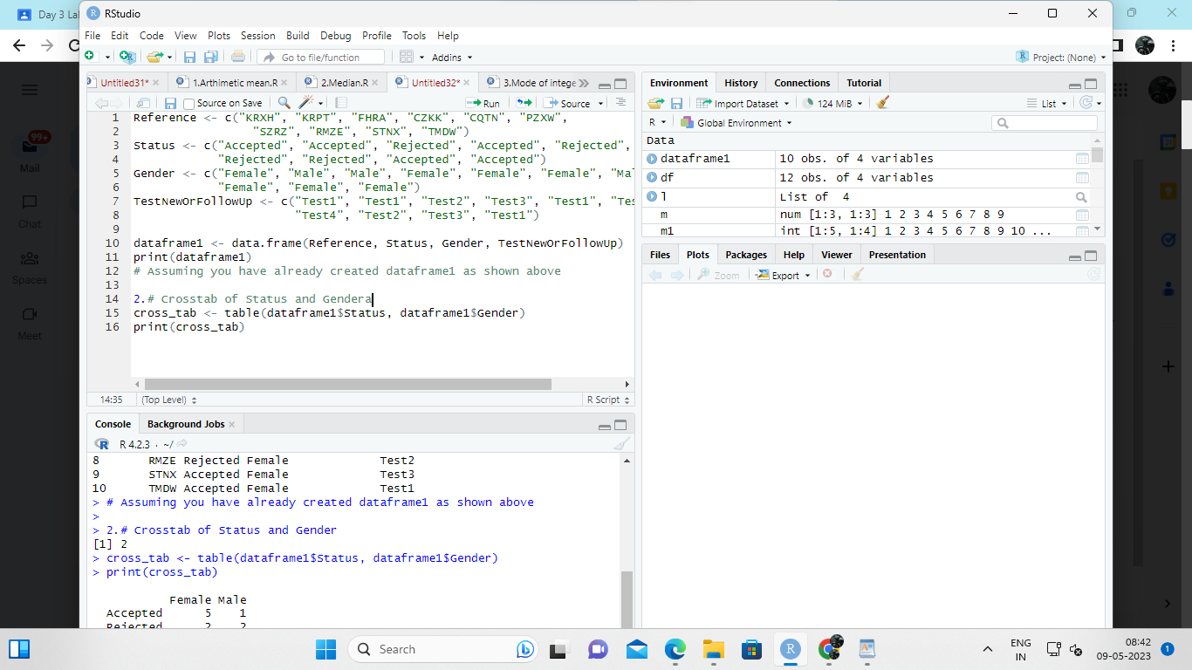

Exercise: 9

i) Use Two Categorical Variables and Discover the relationships within a

dataset

ii) Next, using the xtabs() function, apply two variables from “dataframe1 “, to

create a table delineating the relationship between the “Reference”

category, and the “Status” category.

iii) Save the file in the name of dataframe2

INPUT:

# create dataframe1

dataframe1 <- data.frame(

Reference = c("A", "A", "B", "B", "C", "C", "D", "D"),

Status = c("Complete", "Incomplete", "Complete", "Incomplete", "Complete", "Incomplete",

"Complete", "Incomplete")

)

# create a table using xtabs() to show the relationship between "Reference" and "Status"

dataframe2 <- xtabs(~ Reference + Status, data = dataframe1)

# view the resulting table

dataframe2

OUTPUT:

> # create dataframe1

> dataframe1 <- data.frame(

+ Reference = c("A", "A", "B", "B", "C", "C", "D", "D"),

+ Status = c("Complete", "Incomplete", "Complete", "Incomplete", "Complete", "Incomplete",

+ "Complete", "Incomplete")

+ )

> # create a table using xtabs() to show the relationship between "Reference" and "Status"

> dataframe2 <- xtabs(~ Reference + Status, data = dataframe1)

> # view the resulting table

> dataframe2

Status

Reference Complete Incomplete

A 1 1

B 1 1

C 1 1

D 1 1

>

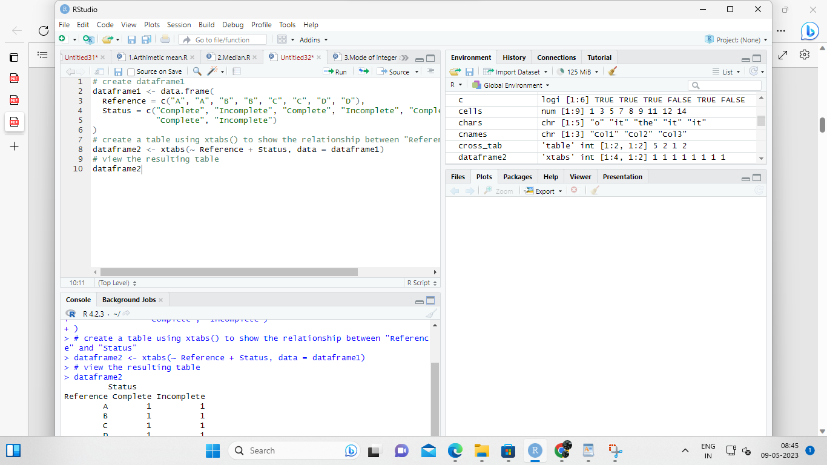

Exercise: 10

Use the same data frame using three Categorical Variables create a Multi-Dimensional Table

Apply three variables from “dataframe1” to create a Multi-Dimensional Cross-Tabulation of

“Status“, “Gender“, and “Test“

INPUT:

dataframe1 <- data.frame(

Status = c("Complete", "Complete", "Incomplete", "Incomplete", "Complete", "Complete",

"Incomplete", "Incomplete"),

Gender = c("Male", "Male", "Male", "Male", "Female", "Female", "Female", "Female"),

Test = c("Test A", "Test B", "Test A", "Test B", "Test A", "Test B", "Test A", "Test B")

)

dataframe2 <- xtabs(~ Status + Gender + Test, data = dataframe1)

dataframe2

OUTPUT:

> dataframe1 <- data.frame(

+ Status = c("Complete", "Complete", "Incomplete", "Incomplete", "Complete", "Complete",

+ "Incomplete", "Incomplete"),

+ Gender = c("Male", "Male", "Male", "Male", "Female", "Female", "Female", "Female"),

+ Test = c("Test A", "Test B", "Test A", "Test B", "Test A", "Test B", "Test A", "Test B")

+ )

> dataframe2 <- xtabs(~ Status + Gender + Test, data = dataframe1)

> dataframe2

, , Test = Test A

Gender

Status Female Male

Complete 1 1

Incomplete 1 1

, , Test = Test B

Gender

Status Female Male

Complete 1 1

Incomplete 1 1

>

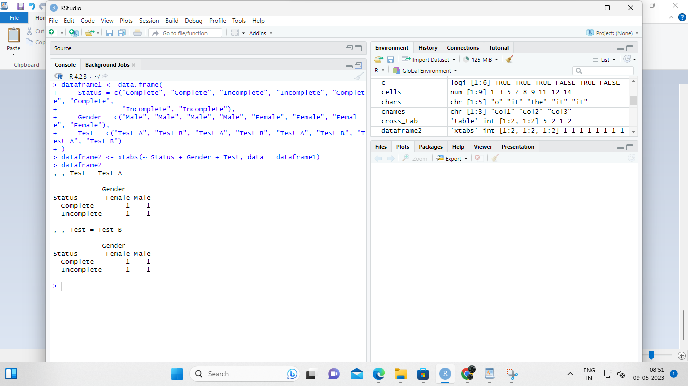

Exercise: 11

Row Percentages

The R package “tigerstats” is required for the next two exercises.

1) Create an xtabs() formula that cross-tabulates “Status“, and “Test“.

2) Enclose the xtabs() formula in the tigerstats function, “rowPerc()” to display row

percentages for “Status” by “Test“.

INPUT:

# load tigerstats package

library(tigerstats)

# create a data frame with Status and Test columns

df <- data.frame(Status = c("Pass", "Pass", "Fail", "Fail", "Pass", "Fail"),

Test = c("A", "B", "A", "B", "B", "A"))

# cross-tabulate Status and Test using xtabs()

xtabs(~ Status + Test, data = df)

OUTPUT:

Test

Status A B

Fail 2 1

Pass 1 2

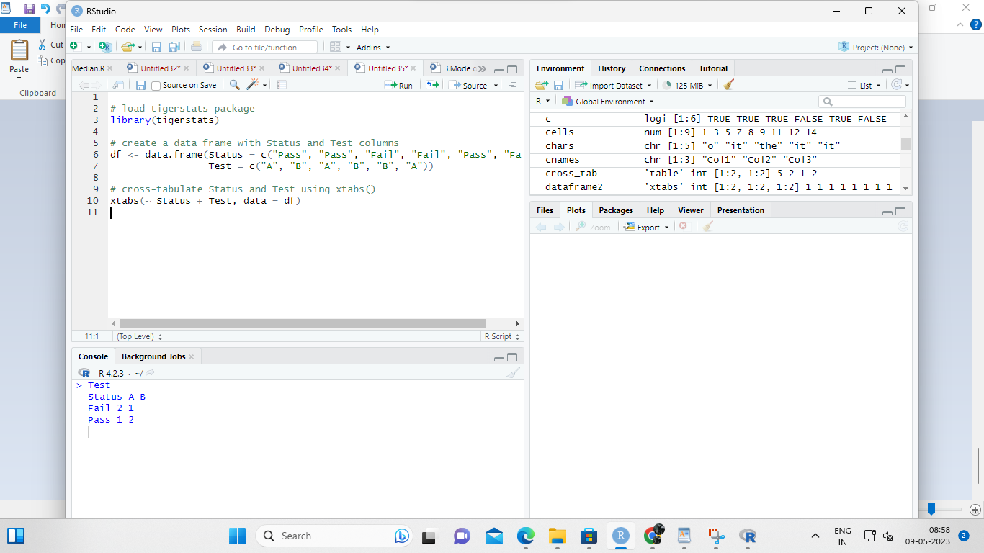

**2. # load tigerstats package**

**library(tigerstats)**

**# create a data frame with Status and Test columns**

**df <- data.frame(Status = c("Pass", "Pass", "Fail", "Fail", "Pass", "Fail"),**

**Test = c("A", "B", "A", "B", "B", "A"))**

**# use rowPerc() to display row percentages for Status by Test**

**rowPerc(xtabs(~ Status + Test, data = df))**

**OUTPUT:**

**Test**

**Status A B**

**Fail 67% 33%**

**Pass 33% 67%**

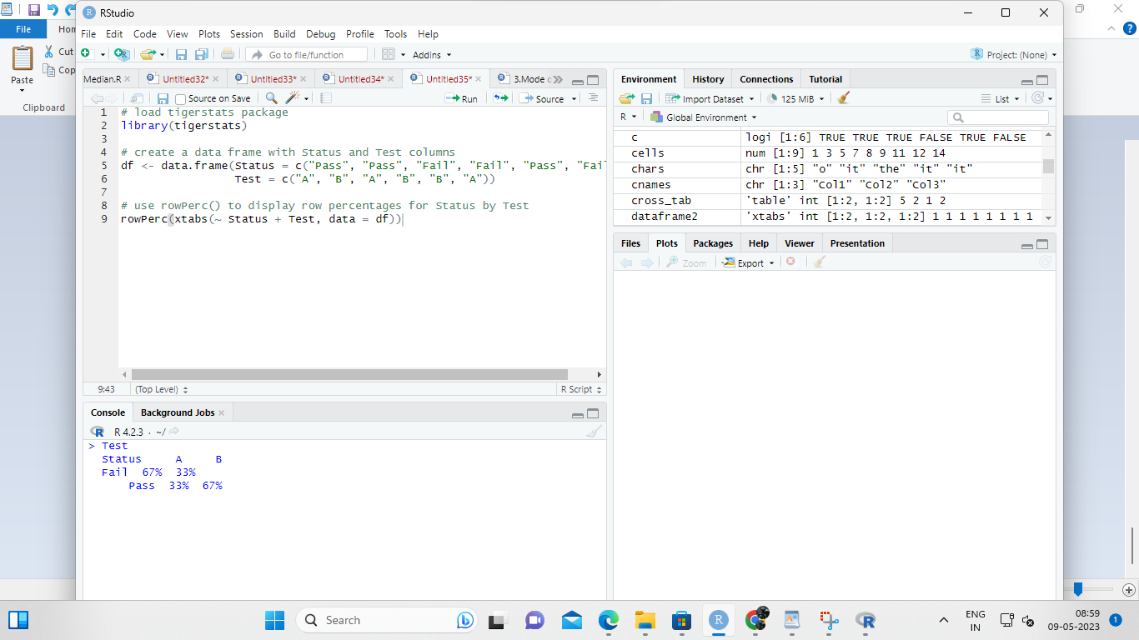

**Exercise 12**

**Column Percentages**

**1) Create an xtabs() formula that cross-tabulates “Status“, and “Test“.**

**2) Enclose the xtabs() formula in the tigerstats function, “colPerc()” to display row**

**percentages for “Status” by “Test“.**

**INPUT:**

**library(tigerstats)**

**# Create a sample data frame**

**mydata <- data.frame(**

**Status = c("Yes", "No", "No", "Yes", "Yes", "No", "No", "Yes"),**

**Test = c("A", "B", "C", "B", "C", "A", "B", "C")**

**)**

**# Create a cross-tabulation of "Status" and "Test" using xtabs()**

**mytable <- xtabs(~ Status + Test, data = mydata)**

**# Calculate column percentages using colPerc()**

**col_perc <- colPerc(mytable)**

**col_perc**

**OUTPUT:**

**Test**

**Status A B C**

**No 50 66.67 33.33**

**Yes 50 33.33 66.67**

**Total 100 100.00 100.00**

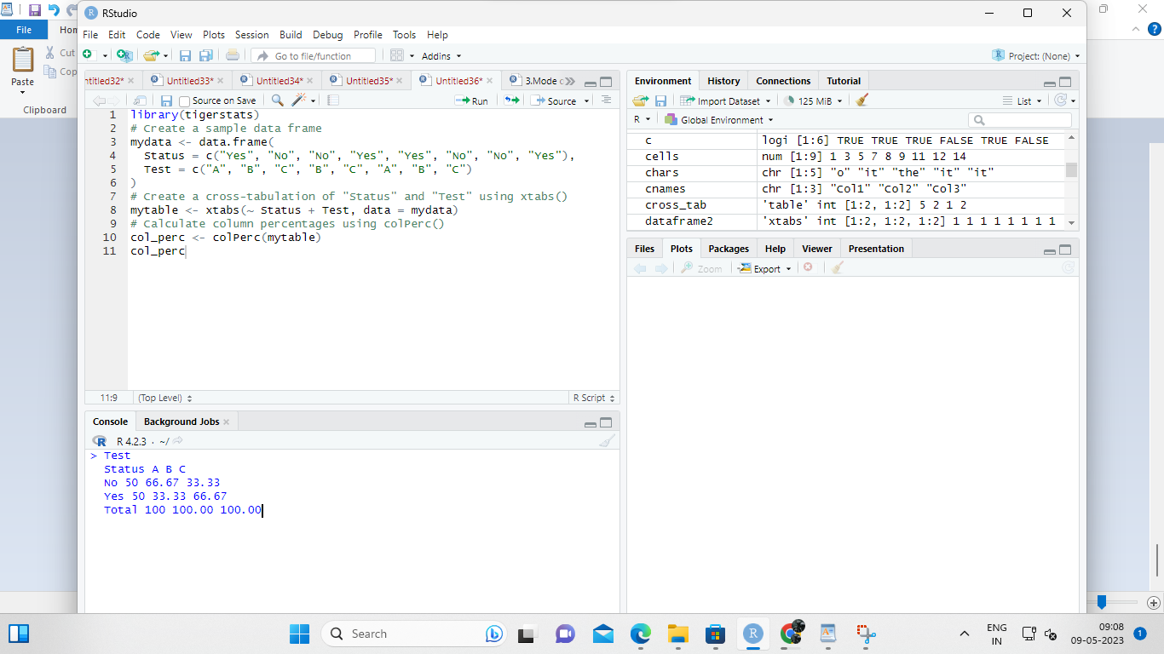

**VISUALIZATION IN R**

**13. Write a program for creating a pie-chart in R using the input vector(21,62,10,53). Provide**

**labels for the chart as ‘London’, ‘New York’, ‘Singapore’, ‘Mumbai’. Add a title to the**

**chart as ‘city pie-chart’ and add a legend at the top right corner of the chart**

**INPUT:**

**# Create data for the graph.**

**geeks<- c(23, 56, 20, 63)**

**labels <- c("Mumbai", "London", "Singapore", "New York")**

**# Plot the chart with title and rainbow**

**# color pallet.**

**pie(geeks, labels, main = "City pie chart",**

**col = rainbow(length(geeks)))**

**OUTPUT:**

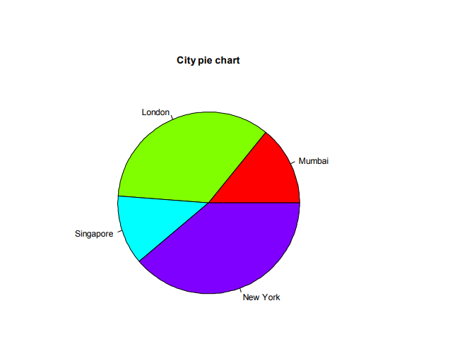

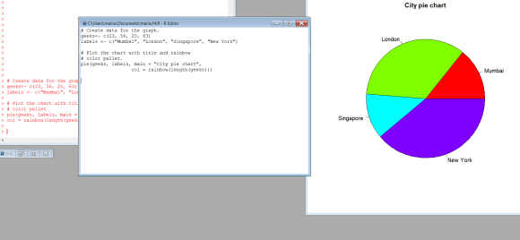

**14. Create a 3D Pie Chart for the dataset “political Knowledge” with suitable labels,colours**

**and a legend at the top right corner of the chart**

**INPUT:**

**library(plotrix)**

**political_knowledge <- data.frame(Category = c("A", "B", "C", "D"),**

**Percentage = c(21, 62, 10, 53))**

**pie3D(political_knowledge$Percentage, labels = political_knowledge$Category,**

**col = c("#1f77b4", "#ff7f0e", "#2ca02c", "#d62728"),**

**explode = 0.05, main = "Political Knowledge")**

**OUTPUT:**

**OUTPUT:**

**Political Knowledge**

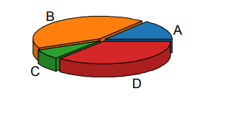

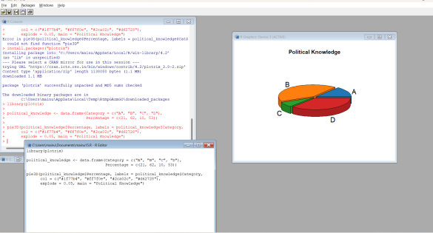

**15. Write a program for creating a bar chart using the vectors H=c(7,12,28,3,41) and**

**M=c(“mar”, “apr”, “may”, “jun”, “jul”). Add a title to the chart as “Revenue chart”.**

**# Define the data vectors**

**H <- c(7, 12, 28, 3, 41)**

**M <- c("mar", "apr", "may", "jun", "jul")**

**# Create the bar chart and save it to a PDF file**

**pdf("revenue_chart.pdf")**

**barplot(H, names.arg = M, main = "Revenue chart")**

**dev.off()**

**OUTPUT:**

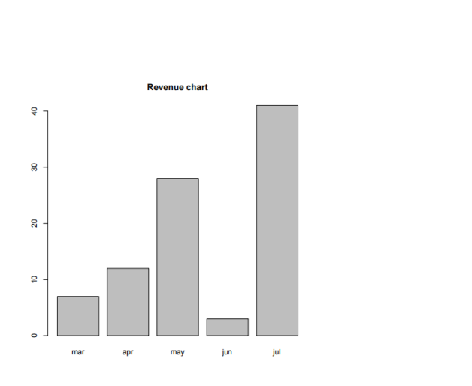

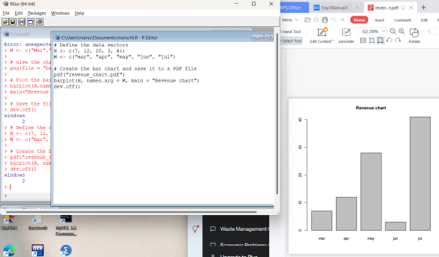

**16. Make a histogram for the “AirPassengers“dataset, start at 100 on the x-axis, and from**

**values 200 to 700, make the bins 200 wide**

**INPUT:**

**# Load the AirPassengers dataset**

**> data(AirPassengers)**

**>**

**> # Create the histogram with custom bin widths and starting point**

**> hist(AirPassengers, breaks=seq(100, 700, 200), xlab="Passenger count",**

**main="AirPassengers histogram")**

**OUTPUT:**

**AirPassengers histogram**

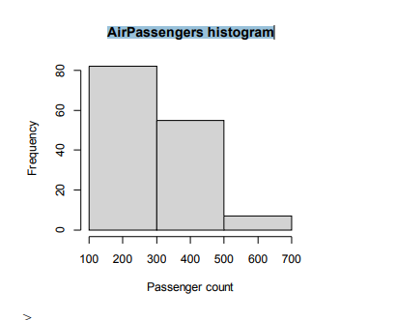

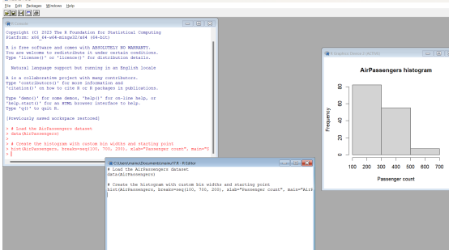

**17. Create a Boxplot graph for the relation between "mpg"(miles per galloon) and**

**"cyl"(number of Cylinders) for the dataset "mtcars" available in R Environment.**

**# Load the mtcars dataset**

**> data(mtcars)**

**>**

**> # Create a boxplot for the relationship between mpg and cyl**

**> boxplot(mpg ~ cyl, data=mtcars, xlab="Number of cylinders", ylab="Miles per**

**gallon", main="mpg vs cyl Boxplot")**

**>**

**OUTPUT:**

